**SMART HOME APPLICATION : GAS DETECTOR**

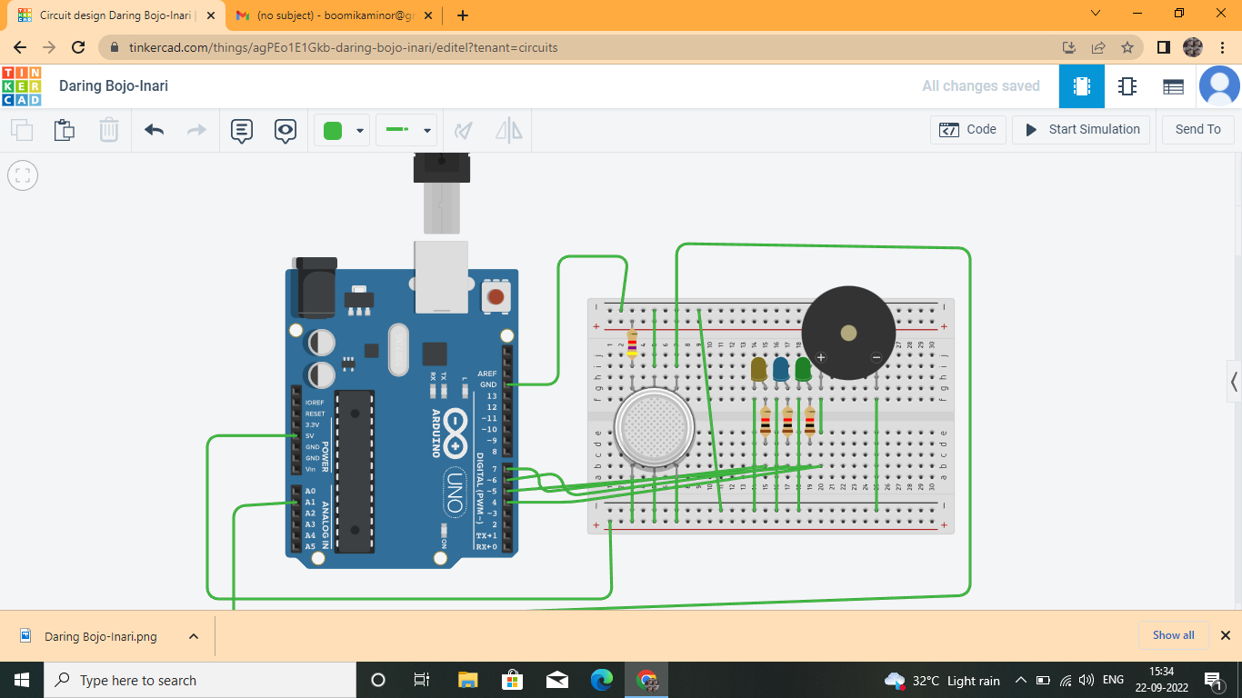

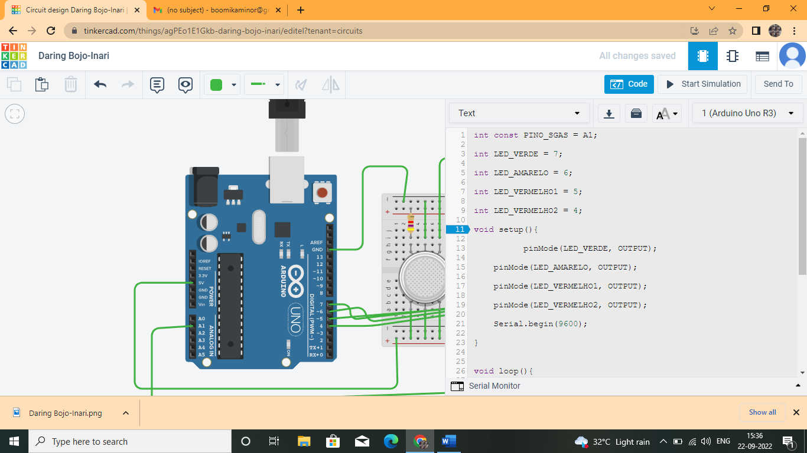

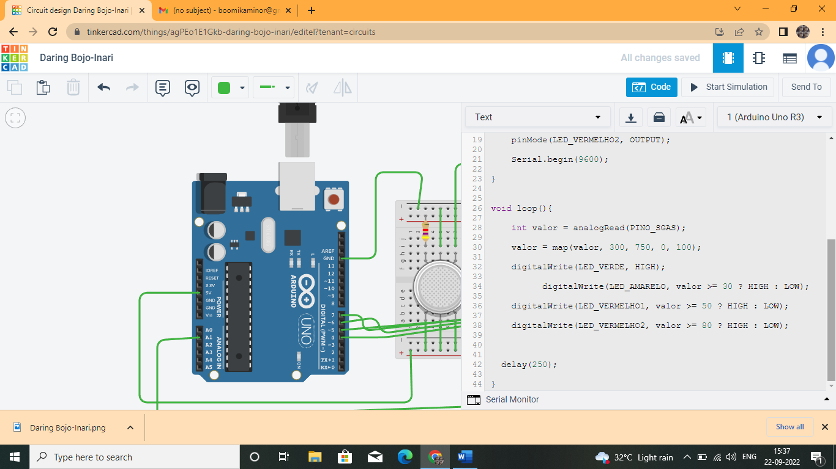

**COMPONENTS USED:**

* Arduino UNO
* Buzzer
* Gas Sensor
* LED
* Resistor

**CODE:**

|  |  |  |  |  |
| --- | --- | --- | --- | --- |
|  | int const PINO_SGAS = A1;  int LED_VERDE = 7;  int LED_AMARELO = 6;  int LED_VERMELHO1 = 5;  int LED_VERMELHO2 = 4;  void setup(){            pinMode(LED_VERDE, OUTPUT);      pinMode(LED_AMARELO, OUTPUT);      pinMode(LED_VERMELHO1, OUTPUT);      pinMode(LED_VERMELHO2, OUTPUT);      Serial.begin(9600);  }  void loop(){      int valor = analogRead(PINO_SGAS);      valor = map(valor, 300, 750, 0, 100);      digitalWrite(LED_VERDE, HIGH);            digitalWrite(LED_AMARELO, valor >= 30 ? HIGH : LOW);      digitalWrite(LED_VERMELHO1, valor >= 50 ? HIGH : LOW);      digitalWrite(LED_VERMELHO2, valor >= 80 ? HIGH : LOW);    delay(250);}   |  |  | | --- | --- | |  |  | |  |